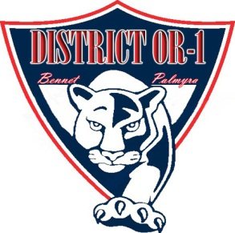
PANTHER PROWL
Newsletter

Together, we prepare our students to successfully
meet the challenges of the future.
,

Bennet Elementary
District OR 1

March 1, 2018
Volume 1, Issue 26

From Mrs. Walter
What a busy week we have had with all of the fun Dr. Seuss activities. The students enjoyed the dress up days and all the Dr. Seuss trivia. Thank you to the Bennet Boosters for the fabulous cookies to celebrate the week. Everyone enjoyed this special treat!

Next Tuesday, motivational speaker Demoine Adams will be talking to students in 5th-8th grades at PHS about positive choices. 5th and 6th grade students will be transported to Palmyra High School by bus at 8:40. Please make sure your child is on time to school.

No school tomorrow, Friday, March 2nd and
no school on Friday, March 9th. There will be an early dismissal at 1:10 on Thursday, March 8th.

Hope to see you at the Family Reading Night tonight (Thursday, March 1st) from 6:30-8:00 PM. The Scholastic Book Fair will be in the library until 8:00 PM.

Thanks for your involvement and support. Please contact me with any questions.

Mrs. Walter

Congratulations Bennet Elementary on a successful caring project. District OR1 raised over 2,200 pounds of food for the Food Bank of Lincoln.
Malcolm Music Contest
The Bennet Singers and band solo & ensembles will be performing at Malcolm Music Contest on Thursday, March 15th.
Students performing at Malcolm will wear their blue Bennet music shirts. Please make sure your student has black dress pants and dress shoes that fit. (No tights please.)

Character Counts
Our Character Counts Pillar of the Month is
“Citizenship.”

To show citizenship means to:

- Do your share to make your school and community better
- Cooperate
- Get involved in your community
- Stay informed and vote
- Be a good neighbor
- Obey laws and rules
- Respect authority
- Protect the environment
- Volunteer

SAVE THE DATE
Bennet Boosters
Family Fun Night April 13th
Palmyra Library
MOVIE NIGHT

The Palmyra Memorial Library will be hosting Movie Night on Friday, March 2nd at 7:00 PM at the Palmyra Activities Center. Grab your pillow and blanket and come enjoy a movie. Snacks will be provided. If you have your water bottle from last summer’s reading program, please bring it. Come and join in the fun.

Summer Enrichment
Save the Date for Summer Enrichment from June 4th-21st. Summer Enrichment will run Monday through Thursday from 9:00 AM to 12:00 PM and is offered to all students entering KDG through 6th grade. Paperwork will be coming home in March.

Upcoming Events
March
-1st Family Reading Night
-2nd No school
-9th No School
-12th B.O.E @ Bennet

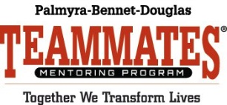

Palmyra-Bennet-Douglas TeamMates
Mentoring Program
Annual Banquet
Sunday, March 18 at 5:30 PM
Palmyra High School
Tickets: $15
Contact: Michael Chaffee,
TeamMates Coordinator,
402-780-5327 Ext. 2018
Chaffee.Mic@districtor1.net

6th Grade Symphony
