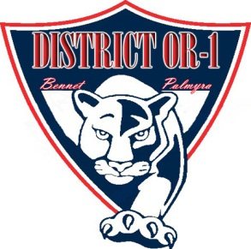
PANTHER PROWL
Newsletter

Together, we prepare our students to successfully
meet the challenges of the future.
,

Bennet Elementary
District OR 1

April 6, 2018
Volume 1, Issue 30

Notes From Mrs. Walter
I can’t believe we are in April! For those of you that like to plan ahead, I want to give you a couple dates for May. The date for our Un-track Day is planned for Friday, May 11th. This is a day where we have stations outside at Bennet Elementary and K-4th students travel with their class through the activities. 5th-6th grade students are bused to the high school where they participate in track events. Parents are welcome to come and watch! This is a fun day for the students. Bennet Awards day is set for Tuesday, May 15th at 2:00 PM.

We will be accepting Summer Enrichment forms through April 13th. Please contact the office or your child’s teacher if you need a new form.

Thank you for your continued support! Mrs. Walter

6th Grade Visit to Palmyra
6th Grade parents please mark your calendars for Wednesday, May 2nd at 5 PM. You and your child are invited to attend a campus visit at Palmyra Junior/Senior High. Members of the Junior/Senior High student body will be available to lead tours and answer questions.

Spring Concert
The 4th-6th grade Spring Concert will be Monday, April 23rd, at 6:30 PM. The concert will be at Palmyra High School.

NSCAS State Wide Assessment
Each spring all students in third through sixth grade complete the Nebraska Student Centered Assessment System Test. It is important that your child be present during these assessments in order to get an accurate picture of his/her level of mastery in relation to the state standards.

April 9-13 will be the NSCAS testing dates at Bennet Elementary.

NSCAS Tests begin this Monday, April 9th for students in 3rd-6th grade.

The following suggestions will help
you support your child during the testing period:
- On the evenings prior to the test, relax and have an enjoyable evening before going to bed.
- Get a good night’s sleep.
- Set the alarm clock to avoid having to rush in the morning.
- Eat a healthy breakfast.
- Arrive at school on time.

Palmyra Memorial Library Hosts Family Game Night
The Palmyra Memorial Library will host Family Game Night on April 28th at 6:30 PM at the Palmyra Activities Center. All children, youth, and their families are welcome to come and play traditional board games and learn new games. Games will be provided by the game hosts Cameron, Angela, Henry, and Samuel Iwan. There will be snacks and door prizes. Come join in the fun!

Bennet Booster Corner

Please mark your calendar for the Bennet Family Fun Night next Friday, April 13th from 6:00-8:00 PM. This will be a fun family event with food, face painting, games, silent auction and much more. We hope to see you there!

Foundation for Knowledge
District OR-1

Join us for Dairy Queen Night out
Wednesday, April 18th, 2018
5pm-8pm
DQ Grill and Chill
8510 Bowman Drive
Lincoln, NE

Teammates Mentoring
Dine at Runza Night
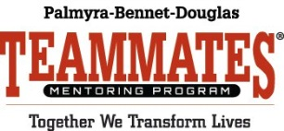

Tuesday, April 10th
8525 Andermatt Drive
(87th & Hwy 2)

Upcoming Events
April
-9th KDG Parent Meeting 6:30 PM
-10th Bennet Booster Meeting
-10th Teammates Runza Night Out
-13th KDG Round Up- No KDG
-16th BOE Meeting at Bennet 7:00 PM
-23rd 4th-6th Grade Spring Concert @ 6:30 PM at PHS

